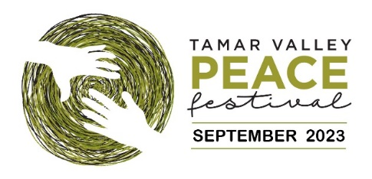

Inviting businesses, groups, and individual peace supporters to think about, and discuss Peace.
Tamar Valley Peace Festival, 2023
Celebrating the International Day of Peace

Tamar Valley Peace Trust invites everyone to make a promise to Peace; to write a message or draw an image of what Peace means to them. This year’s theme is “Connecting – sharing: pathways to peace”.

We have created a Peace Dove template on which staff, clients and customers, or friends and family can write a message, create an image, or colour in. Once the creativity is finished, please cut the doves out and display them in a prominent position during the Tamar Valley Peace Festival.

Things to do:
- Create a motivational display to help convey the message of peace. This could be as simple as an appropriate themed book(s) or poster(s) displayed where staff or customers can see it.
- Print enough doves for your participants.
- Encourage others to express what peace means to them by writing, drawing on or colouring the dove. The Doves could carry “peace promises” where individuals write “promises” to themselves about small everyday ways they can contributed to a more peaceful and kinder society.
- If you intend on displaying your Doves on windows; both sides of the dove can have a message or drawing added.
- Ask participants to cut out the dove and place in your display.

As your collection of Doves grow, we would love you to send photos of the work to be displayed on the Tamar Valley Peace Festival website. As the works are being displayed online, it may be appropriate to check with individuals if they give permission for their work to be viewed publicly.

We look forward to seeing the wonderful works created.

The Peace Festival runs from 17th- 24th September. However, we would love to receive any images you may have before this date to showcase on the website.
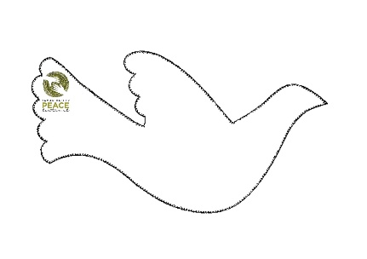
Visit Tamar Valley Peace Festival website to learn more about the
Peace Trust and Festival

Web: http://www.tamarcommunitypeace.org.au/
FB: Tamar Peace Festival Community page
Email: tamar.peace.festival@gmail.com

